

Yenepoya Institute of
Arts, Science, Commerce and Management

Project – Low Level Design
on

Natural Language Interface for Finance Infrastructure

Industry Mentor:

Student Name: Fathima Amna | Guided by: miss manjula

Table of Contents
Contents
1. Introduction 4
1.1. Scope of the Document 4
1.2. Intended Audience 4
1.3. System Overview 4
2. System Design 5
2.1. Application Design 5
2.2. Process Flow 6
Process Flow Diagram 7
2.3. Information Flow 7
2.4. Component Design 8
2.5. Key Design Considerations 11
2.6. API Catalogue 12
3. Data Design 12
Data Diagram 12
3.1. Data Model 12
3.2. Data Access Mechanism 14
3.3. Data Retention Policies 14
3.4. Data Migration 14
4. Interfaces 15
5. State and Session Management 16
6. Caching 17
7. Non-Functional Requirements 17
7.1. Security Aspects 17
7.2. Performance Aspects 18
8. References 19

1. Introduction

1.1. Scope of the Document

This Low Level Design (LLD) document describes the internal implementation of the project Natural Language Interface for Healthcare Infrastructure.
It explains the exact module names, function working, internal logic flow, data structures, and execution process inside each component.
Unlike HLD, which explains the overall architecture, LLD focuses on code-level design such as how each function works, how data moves between modules, and how the chatbot responds to healthcare-related queries.
The document covers the implementation of:
• dataset_loader.py
• response_handler.py
• logger.py
• chatbot.py
• app.py
These modules work together to provide both Website and CLI-based healthcare chatbot support.

1.2. Intended Audience

This document is intended for:
• Developers — to understand how each function and module is implemented
• Testers — to perform testing for specific modules and chatbot responses
• Maintainers — to understand the code structure before future updates
• Reviewers — to verify implementation quality and project requirements
• Faculty and Guides — for academic project evaluation and review

1.3. System Overview
The system includes:
• dataset_loader.py — Loads healthcare dataset from JSON file
• response_handler.py — Performs keyword matching and generates chatbot responses
• logger.py — Saves user queries and chatbot responses in history log file
• chatbot.py — CLI-based chatbot interface for terminal interaction
• app.py — Streamlit website for chatbot and Dashboard History
Both the Website Interface and CLI Interface use the same backend logic, ensuring consistent chatbot responses across both platforms.

2. System Design

2.1. Application Design
The Healthcare Chatbot is divided into five main modules. Each module has a specific responsibility and they work together to provide chatbot responses and history management.
Module / File | Role | Key Functions / Exports
dataset_loader.py | Loads healthcare dataset from JSON file | load_dataset()
response_handler.py | Performs keyword matching and generates responses | get_response()
logger.py | Saves chat history into log file | save_chat()
chatbot.py | CLI chatbot interface for terminal interaction | chatbot loop
app.py | Streamlit web interface + Dashboard History | st.chat_input(), dashboard display

Function signatures
Function | Signature | Returns
load_dataset | load_dataset() | Dataset dictionary
get_response | get_response(user_input, data) | Chatbot response
save_chat | save_chat(user_query, bot_response) | Saved log entry
chatbot loop | while True loop | Continuous CLI execution

2.2. Process Flow
The Healthcare Chatbot processes each query through a simple sequence of steps:
• Step 1 — User Opens Interface:
The user opens the website or runs python chatbot.py in the terminal.
• Step 2 — User Sends a Query:
The user enters a healthcare question like doctor availability, bed status, fever symptoms, or ambulance support.
• Step 3 — Input Processing:
The system reads the input and converts it into a simple format for checking.
• Step 4 — Keyword Matching:
The chatbot checks for keywords like doctor, fever, ambulance, bed, and appointment.
• Step 5 — Response Generation:
The system finds the matching predefined healthcare response.
• Step 6 — Response Display:
The chatbot shows the response to the user on the website or CLI.
• Step 7 — History Saving:
The user query and chatbot response are saved in Dashboard History.

Process Flow Diagram
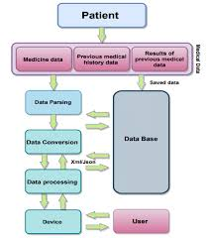

2.3. Information Flow
The Healthcare Chatbot transfers information through different modules in a simple flow.
• Step 1 — User Input:
The user enters a healthcare-related query through the website or CLI.
• Step 2 — Frontend to Backend:
The input is sent to the Python backend for processing.
• Step 3 — Response Handler:
The backend forwards the input to response_handler.py for keyword checking.
• Step 4 — Dataset Access:
The system reads the healthcare dataset using dataset_loader.py.
• Step 5 — Response Selection:
The matching predefined response is selected and returned.
• Step 6 — Logging:
The user query and chatbot response are stored using logger.py.
• Step 7 — Output Display:
The final response is displayed to the user and shown in Dashboard History.

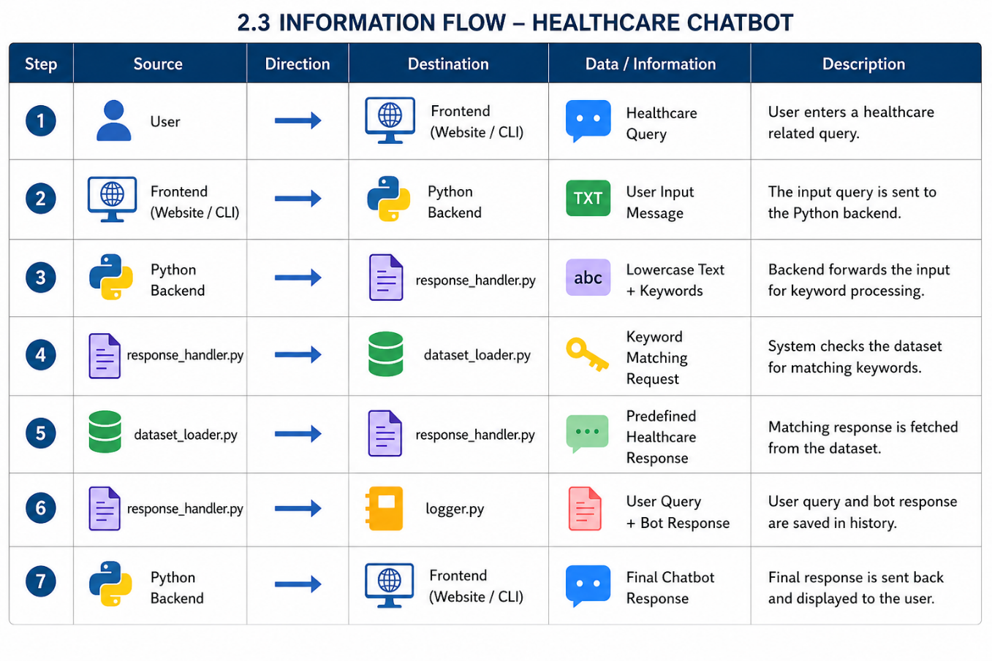

2.4. Component Design
The Healthcare Chatbot system is divided into five main components:
• Dataset Loader (dataset_loader.py)
Loads the healthcare dataset from the JSON file and makes it available for chatbot processing.
• Response Handler (response_handler.py)
Processes user input, performs keyword matching, and selects the correct predefined healthcare response.
• Logger (logger.py)
Stores user queries and chatbot responses in a text file for Dashboard History.
• CLI Module (chatbot.py)
Provides terminal-based chatbot interaction using Python command-line execution.
• Web Interface (app.py)
Provides the Streamlit website interface including chatbot box, navigation buttons, and Dashboard History.
These components work together to make the healthcare chatbot simple, fast, and easy to maintain.

2.5. Key Design Considerations
The Healthcare Chatbot is designed by considering simplicity, performance, and usability.
• Simple Keyword Matching
The system uses basic string matching instead of complex AI models for easy understanding and fast response.
• Dual Interface Support
Both Website (Streamlit) and CLI (Terminal) are supported using the same backend logic.
• Lightweight Dataset
The project uses a JSON dataset instead of a large database for faster loading and simple maintenance.
• Chat History Storage
All user queries and chatbot responses are saved for Dashboard History and future reference.
• Easy Maintenance
Separate Python modules improve code readability, debugging, and future system updates.
These design choices make the project suitable for academic use and practical healthcare support.

2.6. API Catalogue

The Healthcare Chatbot uses simple internal functions instead of complex external APIs.
API/Function | Purpose | Input | Output
load_dataset() | Loads healthcare dataset from JSON file | JSON file | Dataset dictionary
get_response-() | Finds matching healthcare response | User input text | Chatbot response
save_chat() | Stores user query and bot response | Query + Response | Saved log entry
st.chat_input() | Accepts user message from website | User text input | Input string
st.text_area() | Displays Dashboard History logs | Chat history text | Dashboard output

3. Data Design

3.1. Data Model
The Healthcare Chatbot uses a simple JSON-based data model to store predefined healthcare responses.
The dataset contains healthcare-related keywords and corresponding responses for common hospital queries such as doctor availability,

{
"doctor": "Doctors are available from 9 AM to 5 PM.",
"bed": "Current bed availability is 25 beds.",
"ambulance": "Ambulance service is available 24/7.",
"fever": "For fever, please consult the General Medicine department.",
"appointment": "Appointments can be booked at the front desk or online."
}

Data Element | Discription
Keyword | Used for matching user queries
Response | Predefined healthcare reply
User Query | Input entered by the user
Bot Response | Output generated by chatbot
chat History | Stored record of previous conversations
Data Model Compononets:

3.2. Data Access Mechanism
The Healthcare Chatbot uses a simple file-based data access mechanism.
• The system reads healthcare responses from a JSON file using dataset_loader.py.
• The load_dataset() function opens the JSON file and loads all predefined responses into memory.
• When the user enters a query, response_handler.py accesses this loaded data for keyword matching.
• The chatbot selects the matching response and sends it back to the user.
• Chat history is stored separately in a text file using logger.py.
This method is simple, fast, and suitable for small academic projects without requiring a database.

3.3. Data Retention Policies
- The Healthcare Chatbot stores only simple conversation history for reference and dashboard viewing.
- • User queries and chatbot responses are saved in a local text file.
- • No personal medical records or sensitive patient information are stored.
- • The stored chat history is used only for project demonstration and report purposes.
- • Data remains available until the log file is manually deleted or updated.
- • Since the project uses local storage, data management is simple and easy to maintain.
- This policy ensures safe and minimal data handling for the academic healthcare chatbot project.

3.4. Data Migration

The Healthcare Chatbot project uses a simple JSON file instead of a database, so data migration is minimal.
• Healthcare responses are stored in a JSON dataset file.
• If new healthcare services or responses are added, the JSON file can be updated manually.
• Existing chatbot logic automatically works with updated dataset content.
• No complex database migration process is required.
• This makes system updates simple and suitable for academic project development.
The project supports easy future expansion without major structural changes.

4. Interfaces
The Finance Chatbot provides three interface types:
Web Interface (Primary):
The main interface of the Healthcare Chatbot is the Streamlit web application.
• Users can open the chatbot using a web browser.
- The website contains a chatbot button, chatbot box, and Dashboard History section.
- Users can type healthcare-related queries such as doctor availability, bed status, ambulance support, and appointment details.
- The chatbot displays instant responses inside the chat window.
- Previous conversations are shown in the Dashboard History section.
- This interface provides a simple and user-friendly healthcare support experience.
CLI Interface (Secondary):
- The secondary interface is the Command Line Interface (CLI).
• Users can run the chatbot using:
- python chatbot.py
- Queries are entered directly through the terminal.
- The chatbot processes the input and displays predefined responses in text format.
- This interface is mainly used for development, testing, and backend verification.
- The CLI helps understand the core chatbot logic before website integration.

5. State and Session Management
The Healthcare Chatbot uses simple session handling to maintain user interaction during chatbot usage.
• Streamlit session state stores user messages and bot responses during the active website session.
• This helps keep the conversation visible until the page is refreshed.
• Chat history is also saved permanently in a text file using logger.py.
• The saved log file is used for the Dashboard History section.
• In the CLI version, session handling works through a continuous while True loop until the user exits.
This simple session management keeps the chatbot smooth and easy to use without requiring a database.

6. Caching

The Healthcare Chatbot uses a simple caching approach to improve performance.
- The dataset is loaded only once at the start using load_dataset().
- Streamlit session state prevents repeated loading of the same data during interaction.
- This reduces unnecessary processing and improves response speed.
- Frequently used responses are quickly accessed from memory instead of re-reading files.
- Since the dataset is small, advanced caching techniques are not required.
- This approach keeps the system lightweight, fast, and efficient.

7. Non-Functional Requirements

7.1. Security Aspects

The Healthcare Chatbot follows basic security practices suitable for an academic project.

• The system does not store any sensitive personal or medical data.

• Chat history is stored locally in a text file only for demonstration purposes.

• User input is handled safely without executing any external code.

• No database or external server is used, reducing security risks.

• Access to the system is limited to local usage.

This ensures safe and controlled operation of the chatbot.

7.2. Performance Aspects

The Healthcare Chatbot is designed for fast and efficient performance.

• The system uses basic string matching, which is faster than complex AI models.

• The dataset is small and loads quickly.

• Responses are generated instantly without heavy computation.

• The chatbot runs smoothly on normal computers without high system requirements.

• Streamlit provides quick and responsive user interaction.

This makes the system reliable and suitable for real-time healthcare queries.

8. References
• Python Official Documentation
- Streamlit Official Documentation
• Kaggle Healthcare Dataset
• VS Code Official Documentation
- IBM Project Guidelines
- Yenepoya Project Framework 2026
- JSON Documentation
- Basic Natural Language Processing Concepts

